**Homework 3 Solutions**

Question 1:

The code is in the notebook.

Results:

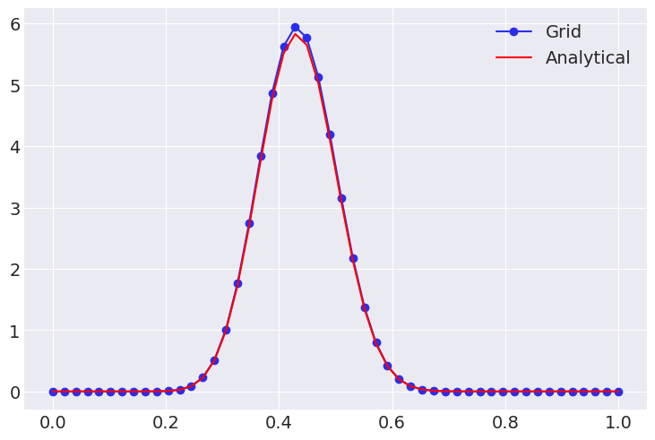

Question 2:

The algorithm is in the notebook.

Results:

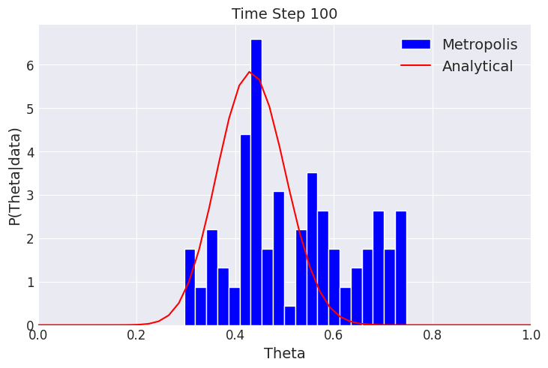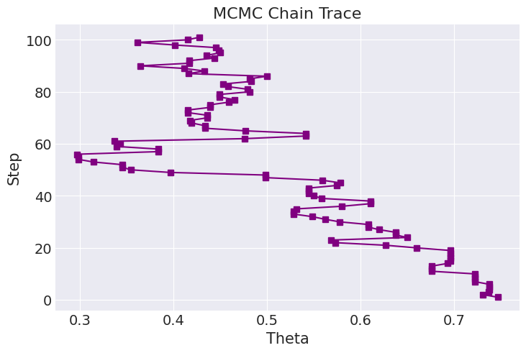

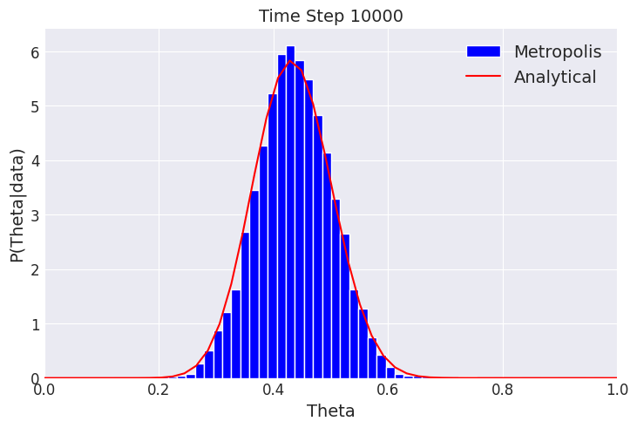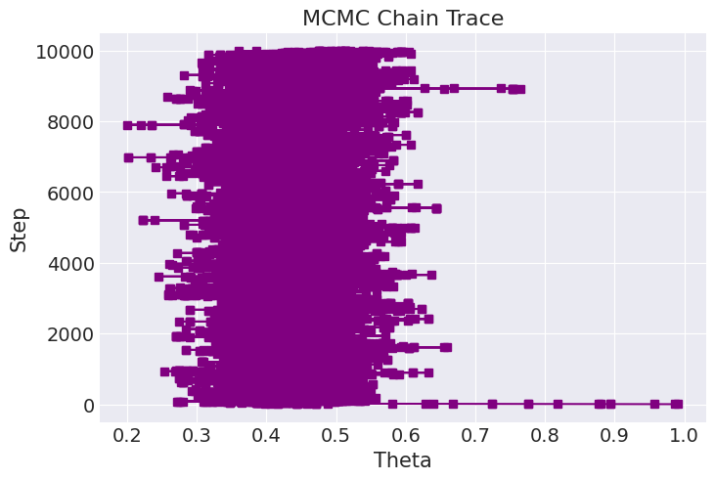

Question 3:

a-c. In the notebook.

d. Based on the overlap between the chains, the fact that all the chains appeared to visit the different parameter values, and the relatively uniform distribution of the rank plots, the visual analyses show no indication of sampling issues. Additionally, there were no divergences.

The Rhat is below 1.1, the ESS is high, and the MCSE is lower than 1%, further supporting the above conclusion.

Question 4:

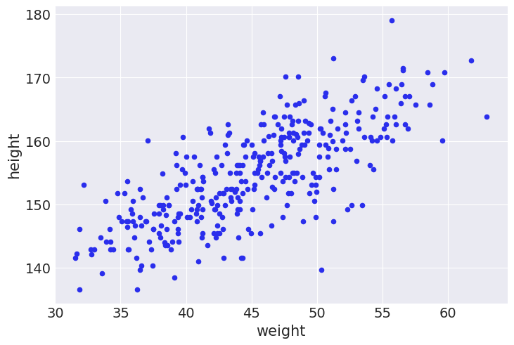



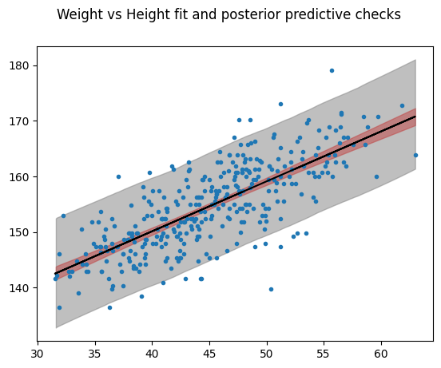



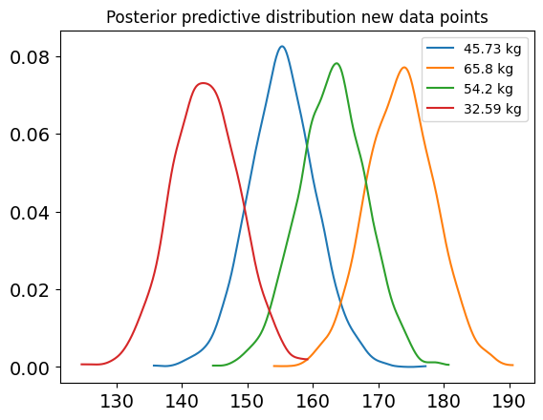



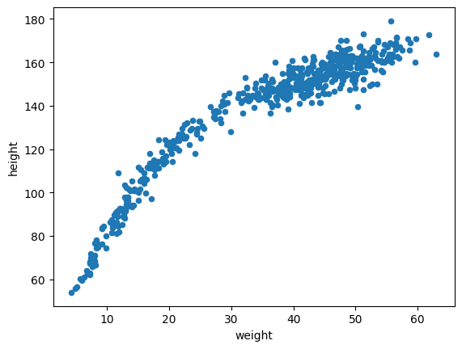

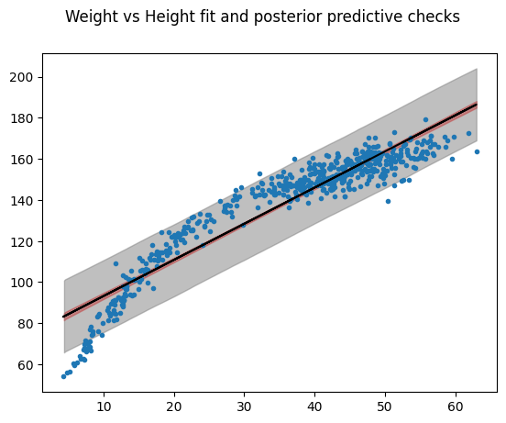



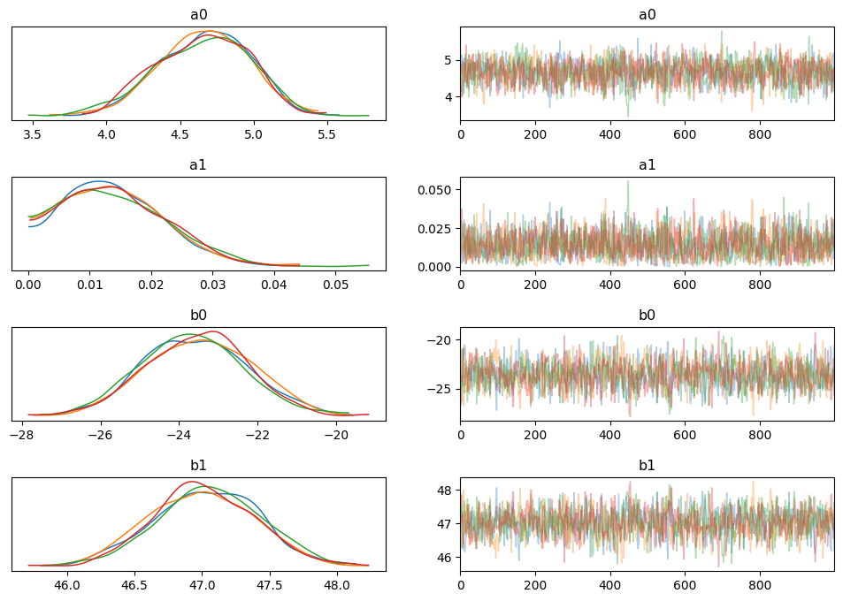

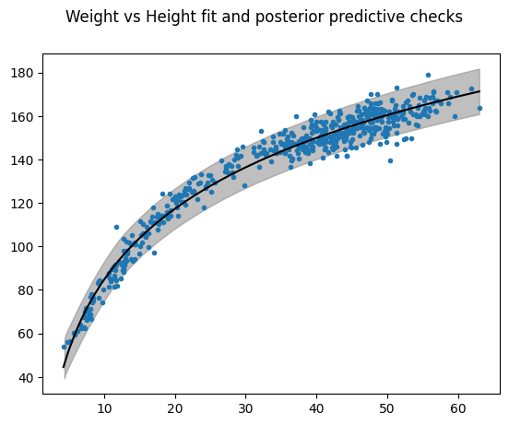

Question 5: